MongoDB Blogging Database 101
A Complete Beginner's Walkthrough
MongoDB Compass + mongosh · blog_app database

1 · What Is NoSQL and How Is It Different from SQL?
Before you write a single command, it helps to understand why MongoDB exists and why it works differently from a traditional SQL database like MySQL or PostgreSQL.

SQL (Relational) Databases
SQL databases store data in rigid tables with fixed columns.
Every row in a table must follow the same structure.
Relationships between tables are enforced using foreign keys — if a comment references a post that does not exist, the database refuses the insert.

NoSQL (Document) Databases
MongoDB is a document database.
Instead of rows and tables, it stores JSON-like objects called documents.
Documents in the same collection do not need to share an identical structure.
MongoDB is more flexible, but that flexibility means you as the developer are responsible for keeping data consistent.

📖 Key Term — Document
One stored record in MongoDB. Think of it like one JavaScript object: { name: 'Alice', email: 'alice@example.com' }. A document can also contain arrays and nested objects inside it.

📖 Key Term — Collection
A group of documents, roughly equivalent to a SQL table. Unlike a SQL table, a collection does not enforce that every document has the same fields.

How the SQL Blog Tables Map to MongoDB
Your original logical data model had four SQL tables: User, Post, Comment, and Like.

In MongoDB we can collapse those into just two collections Users and Posts:

SQL TABLE | MongoDB equivalent COLLECTION | How?
User table | users collection | Each user is its own document
Post table | posts collection | Each post is its own document
Comment table | Embedded inside posts | A comments array inside each post document
Like table | Embedded inside posts | A likes array inside each post document

💡 Why embed comments and likes?
Comments and likes belong to a post. You almost always need them at the same time as the post itself. Embedding means one read operation gets you everything. This is the main performance win of a document database as opposed to a relational one.

💡 Why keep users separate?
A single user can author many posts, leave many comments, and add many likes. Embedding user data inside every post would create huge amounts of duplication. Instead, we store the user's _id on the post and look up the user separately when needed. This is called referencing.

2 · Document Shapes
Below are the exact shapes of the documents you will create.

Read through them before you open MongoDB Compass — understanding the shape first makes every command easier.

2.1 users document
{
_id: ObjectId("..."), // MongoDB creates this automatically
username: "alice",
email: "alice@example.com",
createdAt: ISODate("2026-03-30T00:00:00Z")
}

📖 Key Term — ObjectId
MongoDB's built-in unique identifier type. It is 12 bytes long and contains a timestamp, so it is always unique across the entire database without any extra effort from you. You never type one manually — MongoDB generates it.

2.2 posts document
{
_id: ObjectId("..."),
authorId: ObjectId("..."), // links to a users document

title: "My First Blog Post",
description: "This is my first post.",
imageUrl: "https://example.com/image.jpg", // or null if no image

createdAt: ISODate("2026-03-30T00:00:00Z"),
updatedAt: ISODate("2026-03-30T00:00:00Z"),

comments: [ // embedded array — replaces the Comment table
{
commentId: ObjectId("..."),
userId: ObjectId("..."), // links to a user’s document
commentText: "Great first post!",
createdAt: ISODate("2026-03-30T01:00:00Z")
}
],

likes: [ // embedded array — replaces the Like table
{
userId: ObjectId("..."), // links to a user’s document
createdAt: ISODate("2026-03-30T02:00:00Z")
}
]
}

📖 Key Term — Embedding vs Referencing
Embedding means storing child data (comments, likes) inside the parent document (post). Referencing means storing another document's _id to create a link — for example, authorId on a post references a user document.

3 · Setup — Creating the Database

3.1 Open MongoDB Compass
- Launch MongoDB Compass on your computer.
- You will see a connection screen. The default connection string for a local MongoDB installation is:

mongodb://localhost:27017

- Click Connect. If Compass is already connected from a previous session, skip straight to step 4.
- In the left panel you will see a list of existing databases (admin, config, local are built-in — ignore them).

⚠️ MongoDB Not Running?
If Compass cannot connect, MongoDB itself is probably not running. On macOS run: brew services start mongodb-community On Windows, start the MongoDB service from the Services panel or run mongod in a terminal.

3.2 Create the blog_app Database

In Compass:
- Click the + button next to Databases in the left sidebar.
- In the "Database Name" field type: blog_app
- In the "Collection Name" field type: users (Compass requires at least one collection to create a database)
- Click Create Database.
- Now create the second collection: click the + button next to blog_app in the left sidebar, type posts, and click Create Collection.

Shell equivalent (mongosh):
Open a terminal and run mongosh to start the MongoDB shell. Then:

use blog_app db.createCollection("users") db.createCollection("posts")

💡 What does 'use blog_app' do?
It tells MongoDB which database to work in. If blog_app does not exist yet, MongoDB creates it the moment you add data to it. The shell prompt changes to show the active database.

4 · Indexes — Enforcing Rules and Speeding Up Queries
📖 Key Term — Index
A data structure MongoDB builds alongside your collection to make certain lookups faster and to enforce uniqueness. Without an index on email, MongoDB would scan every document to find a matching email address — slow at scale. With an index, the lookup is near-instant.

Create all six indexes immediately after creating the collections. Run these commands one at a time in mongosh:
db.users.createIndex({ email: 1 }, { unique: true })
db.users.createIndex({ username: 1 }, { unique: true })
db.posts.createIndex({ authorId: 1 })
db.posts.createIndex({ createdAt: -1 })
db.posts.createIndex({ "comments.userId": 1 })
db.posts.createIndex({ "likes.userId": 1 })

4.1 Users indexes
// Prevent two users sharing the same email address
db.users.createIndex({ email: 1 }, { unique: true })

// Prevent two users sharing the same username
db.users.createIndex({ username: 1 }, { unique: true })

Why unique: true? This mirrors the SQL UNIQUE constraint. If you try to insert a second user with the same email, MongoDB will reject the insert with a duplicate key error — exactly what you want.

4.2 Posts indexes
// Find all posts by one author quickly
db.posts.createIndex({ authorId: 1 })

// Return posts in newest-first order efficiently db.posts.createIndex({ createdAt: -1 })

// Find posts that a specific user has commented on db.posts.createIndex({ "comments.userId": 1 })

// Find posts that a specific user has liked db.posts.createIndex({ "likes.userId": 1 })

💡 Indexes on nested array fields
Notice the dot-notation "comments.userId". MongoDB can index fields inside embedded arrays. The index covers every element in every comments array across the whole collection.

💡 1 vs -1
The number sets the sort direction for the index. 1 = ascending (A→Z, oldest→newest). -1 = descending (Z→A, newest→oldest). For a blog, createdAt: -1 is correct because you usually want the newest posts first.

5 · Insert Users

5.1 Run the insertMany command
Copy and paste the following into mongosh. The shell will return the generated _id values for each document.

db.users.insertMany([
{
username: "erson",
email: "erson@example.com",
createdAt: new Date("2026-03-30T00:00:00Z")
},
{
username: "anthony",
email: "anthony@example.com",
createdAt: new Date("2026-03-30T00:05:00Z")
},
{
username: "costan",
email: "costan@example.com",
createdAt: new Date("2026-03-30T00:10:00Z")
}
])

💡 insertMany vs insertOne
insertMany inserts a whole array of documents in one round-trip. insertOne inserts a single document. Use insertMany when you have multiple documents ready — it is faster than calling insertOne in a loop.

5.2 View the inserted documents in Compass
- Click blog_app → users in the Compass left sidebar.
- You will see three documents. Each has an _id that MongoDB generated automatically.
- Click on any document to expand it and see all its fields.
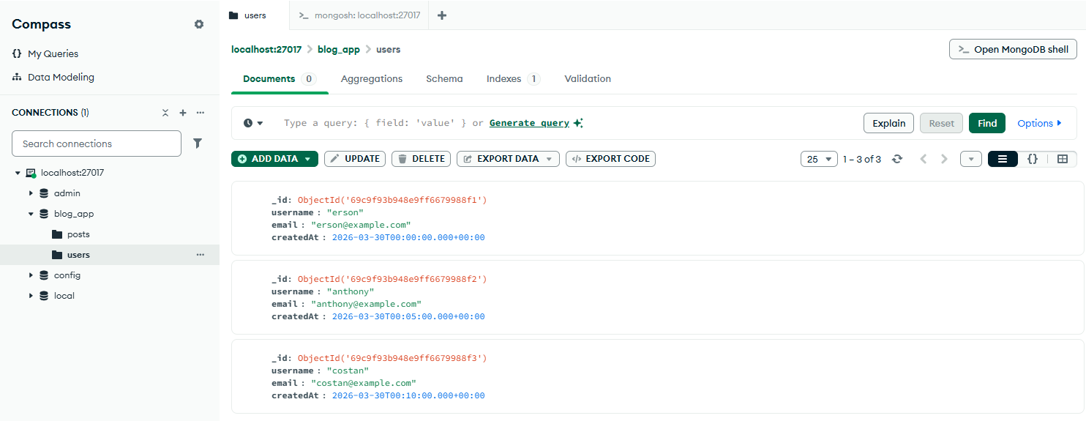

5.3 Copy a user _id
Now You need the _id values to create posts. To copy an _id:
- Hover over the _id field in Compass.
- Click the copy icon that appears.
Alternatively, run this in mongosh to list all users and their _ids:

db.users.find()

⚠️ Save your _id values!
Paste them into a text file now. You will need them in the next section. Each ObjectId looks like: 67e8f4a2c3d5e6b1a9f20001

_id: ObjectId('69c9f93b948e9ff6679988f1'),
username: 'erson',
email: 'erson@example.com',
createdAt: 2026-03-30T00:00:00.000Z

_id: ObjectId('69c9f93b948e9ff6679988f2'),
username: 'anthony',
email: 'anthony@example.com',
createdAt: 2026-03-30T00:05:00.000Z

_id: ObjectId('69c9f93b948e9ff6679988f3'),
username: 'costan',
email: 'costan@example.com',
createdAt: 2026-03-30T00:10:00.000Z

6 · Insert Posts
Replace the placeholder text ALICE_ID_HERE, BOB_ID_HERE, CAROL_ID_HERE with the actual _id strings you copied in the previous step.

⚠️ Exact format matters
ObjectId values must be passed as ObjectId("...") — the 24-character hex string wrapped in double quotes inside the constructor. Do not add spaces or change capitalisation.

db.posts.insertMany([
{
authorId: ObjectId("69c9f93b948e9ff6679988f1"),
title: "Erson’s First Day in Australia ",
description: "Hello world! I am Erson this is my very first day working in Australia as a software engineer.",
imageUrl: "https://example.com/images/post1.jpg",
createdAt: new Date("2026-03-30T08:00:00Z"),
updatedAt: new Date("2026-03-30T08:00:00Z"),
comments: [],
likes: []
},
{
authorId: ObjectId("69c9f93b948e9ff6679988f2"),
title: "Anthony makes a cartoon game.",
description: "Gaming is actually pretty fun once you get used to it!",
imageUrl: null,
createdAt: new Date("2026-03-30T09:00:00Z"),
updatedAt: new Date("2026-03-30T09:00:00Z"),
comments: [],
likes: []
},
{
authorId: ObjectId("69c9f93b948e9ff6679988f3"),
title: "Costan’s first property buying app ever",
description: "Hi everyone, I just created an app allowing you to bypass property agents!",
imageUrl: "https://example.com/images/bob1.jpg",
createdAt: new Date("2026-03-30T10:00:00Z"),
updatedAt: new Date("2026-03-30T10:00:00Z"),
comments: [],
likes: []
}
])

Why do comments and likes start as empty arrays? Because MongoDB requires the field to exist with the correct type before you can use $push to add items into it. An empty array [] is the correct starting value.

Why can imageUrl be null? Not every blog post has a header image. Storing null explicitly is clearer than omitting the field — it signals that you checked and there is no image, rather than that you forgot.

Why do we store both createdAt and updatedAt? createdAt records when the post was first published and never changes. updatedAt records the most recent edit. You will update updatedAt every time you change the post.

7 · Add Comments
📖 Key Concept — $push
$push is a MongoDB update operator that appends a new item to the end of an array field. You do not replace the whole array — you add one item to whatever is already there.

Replace POST_ID_HERE and USER_ID_HERE with real _id values before running:

db.posts.updateOne(
{ _id: ObjectId("69c9fb51948e9ff6679988f4") }, // use the correct post id
{
$push: {
comments: {
commentId: ObjectId(), // new unique id for the comment
userId: ObjectId("69c9f93b948e9ff6679988f2"),
commentText: "Welcome to Australia mate! Cheers, Anthony.",
createdAt: new Date()
}
},
$set: {
updatedAt: new Date()
}
}
)

Why is this an update and not an insert? The comment does not get its own document in a separate collection. It lives inside the post document. Updating the post is the correct operation.

Why does each comment get its own commentId? So you can later identify a specific comment when you want to edit or delete just that one comment. Without an id, you would have to match on the text content, which is unreliable.

Why $set updatedAt at the same time? MongoDB can run $push and $set together in a single updateOne call. Combining them in one command is more efficient than two separate calls.

8 · Add Likes — With a Duplicate-Prevention Guard
In the original SQL design, the Like table used a composite primary key (postId + userId). That made it physically impossible for the same user to like the same post twice — the database rejected the insert automatically.

In the embedded NoSQL design, there is no composite key on an array. We have to mimic this protection ourselves using a guarded update.

📖 Key Concept — $ne (not equal)
The filter "likes.userId": { $ne: ObjectId("USER_ID") } means "only match this post if the likes array does NOT already contain an object with this userId." If the user has already liked the post, the filter finds no matching document and nothing is updated.

db.posts.updateOne(
{
_id: ObjectId("69c9f93b948e9ff6679988f1"),
"likes.userId": { $ne: ObjectId("69c9f93b948e9ff6679988f3") } // guard: skip if already liked
},
{
$push: {
likes: {
userId: ObjectId("69c9f93b948e9ff6679988f3"),
createdAt: new Date()
}
},
$set: {
updatedAt: new Date()
}
}
)

💡 How to check if the guard worked
updateOne returns a result object with a matchedCount field. If matchedCount is 0, the filter found no matching document — meaning the user had already liked the post and the like was NOT added. If matchedCount is 1, the like was added successfully.

⚠️ This is one of the most important SQL→NoSQL thinking shifts
SQL enforced no-duplicate-likes at the database level automatically. MongoDB requires you to write the guard yourself. If you forget the $ne filter, duplicate likes can accumulate silently. Always use this pattern when adding likes.

9 · Querying Data

9.1 Show all users
db.users.find()
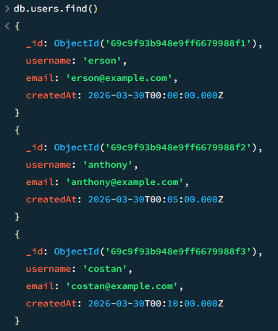

9.2 Show all posts
db.posts.find()

💡 Too much output?
Add .limit(5) to see only the first five results: db.posts.find().limit(5)

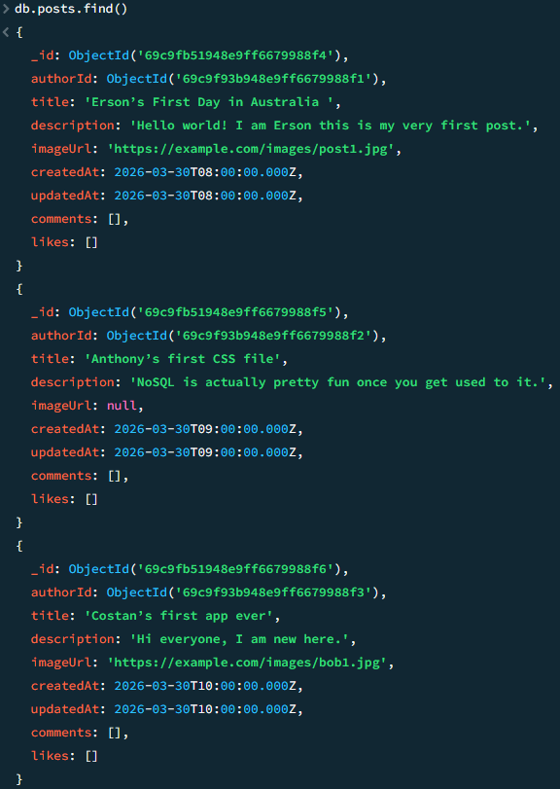

9.3 Show all posts by one author
db.posts.find({ authorId: ObjectId("69c9f93b948e9ff6679988f1") })

db.posts.find({ authorId: ObjectId("69c9f93b948e9ff6679988f2") })

db.posts.find({ authorId: ObjectId("69c9f93b948e9ff6679988f3") })

No need.

9.4 Show one post and all its comments
db.posts.findOne({ _id: ObjectId("69c9fb51948e9ff6679988f4") })

findOne returns one document (with all its embedded comments and likes). find() returns a cursor over multiple documents.
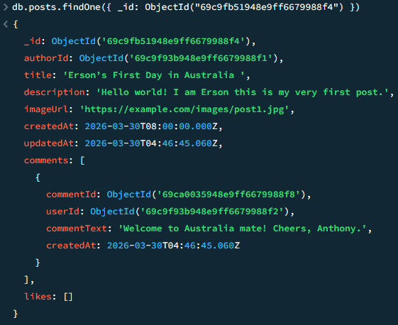

9.5 Show only the title and like count of a post
This uses projection — asking MongoDB to return only specific fields:

db.posts.findOne(
{ _id: ObjectId("POST_ID_HERE") },
{
title: 1,
likes: 1,
_id: 0 // 1 = include, 0 = exclude
}
)

9.6 Find posts liked by a specific user
db.posts.find({ "likes.userId": ObjectId("69c9f93b948e9ff6679988f3") })

9.7 Find posts commented on by a specific user
db.posts.find({ "comments.userId": ObjectId("69c9f93b948e9ff6679988f2") })

9.8 Count likes on a post
// Option 1: Fetch the post, then check likes.length in your application

// Option 2: Use aggregation to count likes directly
db.posts.aggregate([
{
$match: {
_id: ObjectId("POST_ID_HERE")
}
},
{
$project: {
title: 1,
likeCount: {
$size: "$likes"
}
}
}
])

💡 What is aggregate?
$aggregate lets you transform and summarise data in the database before it is returned. $size counts the number of elements in an array. This is the MongoDB equivalent of COUNT() in SQL.

10 · Updating Data

10.1 Edit a post title and description
db.posts.updateOne(
{ _id: ObjectId("69c9fb51948e9ff6679988f4") },
{
$set: {
title: "Updated Title",
description: "Updated description text.",
updatedAt: new Date()
}
}
)

10.2 Update or remove a post image
// Set a new image URL
db.posts.updateOne(
{ _id: ObjectId("69c9fb51948e9ff6679988f4") },
{
$set: {
imageUrl: "https://example.com/new-image.jpg",
updatedAt: new Date()
}
}
)

// Remove the image (set to null)
db.posts.updateOne(
{ _id: ObjectId("POST_ID_HERE") },
{
$set: {
imageUrl: null,
updatedAt: new Date()
}
}
)

10.3 Edit a specific embedded comment
This is where beginners most often get stuck. You cannot use a simple $set on the array — you need arrayFilters to target the right comment by its commentId.

db.posts.updateOne(
{ _id: ObjectId("69c9fb51948e9ff6679988f4") },
{
$set: {
"comments.$[elem].commentText": "Edited comment text.",
updatedAt: new Date()
}
},
{
arrayFilters: [
{ "elem.commentId": ObjectId("COMMENT_ID_HERE") }
]
}
)

📖 How arrayFilters works
"comments.$[elem]" means: look inside the comments array and apply the change to the element matched by the filter named elem. The arrayFilters option defines what elem means: the comment whose commentId equals the one you provide. Only that single comment is updated.

11 · Deleting Data
📖 Key Term — $pull
$pull removes items from an array that match a condition. It is the opposite of $push.

11.1 Delete a specific comment from a post
db.posts.updateOne(
{ _id: ObjectId("POST_ID_HERE") },
{
$pull: {
comments: {
commentId: ObjectId("COMMENT_ID_HERE")
}
},
$set: {
updatedAt: new Date()
}
}
)

11.2 Remove a like from a post
db.posts.updateOne(
{ _id: ObjectId("POST_ID_HERE") },
{
$pull: {
likes: {
userId: ObjectId("USER_ID_HERE")
}
},
$set: {
updatedAt: new Date()
}
}
)

11.3 Delete an entire post
db.posts.deleteOne({ _id: ObjectId("POST_ID_HERE") })

11.4 Delete a user — and the orphan-reference problem
db.users.deleteOne({ _id: ObjectId("USER_ID_HERE") })

⚠️ Important: MongoDB has no foreign key cascade
In SQL, a foreign key with ON DELETE CASCADE would automatically remove all posts, comments, and likes belonging to a deleted user. MongoDB has no equivalent. After deleting a user document, every post where authorId equals that user's _id, every comment where userId equals that _id, and every like where userId equals that _id will still exist — but will now point to a user document that no longer exists. These are called orphan references. You must clean them up yourself. A typical approach is to run db.posts.deleteMany({ authorId: ObjectId("USER_ID_HERE") }) to delete the user's posts before deleting the user.

12 · Optional Next Steps
Everything in this section is optional. Complete the core build first. Come back here when you are comfortable with the basics.

12.1 Add JSON Schema Validation
Schema validation tells MongoDB to reject documents that do not match a required shape. Add it to the users collection like this:

db.runCommand({
collMod: "users",
validator: {
$jsonSchema: {
bsonType: "object",
required: ["username", "email", "createdAt"],
properties: {
username: {
bsonType: "string"
},
email: {
bsonType: "string"
},
createdAt: {
bsonType: "date"
}
}
}
}
})

12.2 Add a post status field
Add a status field to posts with the value "draft" or "published":

db.posts.updateOne(
{ _id: ObjectId("POST_ID_HERE") },
{
$set: {
status: "published",
updatedAt: new Date()
}
}
)

12.3 Add tags to posts
db.posts.updateOne(
{ _id: ObjectId("POST_ID_HERE") },
{
$set: {
tags: ["mongodb", "beginner", "nosql"],
updatedAt: new Date()
}
}
)

12.4 Top liked posts — aggregation pipeline
db.posts.aggregate([
{
$project: {
title: 1,
likeCount: { $size: "$likes" }
}
},
{
$sort: {
likeCount: -1
}
},
{
$limit: 5
}
])

13 · Test Checklist
Work through each scenario below in order. Each one verifies a different part of the design. If any step fails, the section number tells you where to look for the fix.

# | Scenario | Expected Result / Section
1 | Create two users with the same email address | Second insert fails with duplicate key error → Section 4
2 | Create multiple posts for one user | All posts share the same authorId → Section 6
3 | Add comments from different users to the same post | All comments appear in the comments array → Section 7
4 | Add likes from different users to the same post | All likes appear in the likes array → Section 8
5 | Like the same post twice from the same user | Second like is silently ignored; matchedCount returns 0 → Section 8
6 | Query all posts by one user | Only posts with that authorId are returned → Section 9.3
7 | Edit a post title and confirm updatedAt changes | New title and new timestamp appear in the document → Section 10.1
8 | Delete one specific comment | Only that comment disappears; the rest remain → Section 11.1
9 | Remove a like and check the array length | likeCount decreases by 1 → Section 11.2
10 | Delete a user and query their posts | Posts still exist but their authorId now points to nothing → Section 11.4

Quick Reference — Common Commands
Task | Command
Switch database | use blog_app
List all collections | show collections
Count documents | db.users.countDocuments()
Find all | db.posts.find()
Find one | db.posts.findOne({ _id: ObjectId('...') })
Insert one | db.users.insertOne({ ... })
Insert many | db.users.insertMany([ ... ])
Update one field | db.posts.updateOne({ _id: ... }, { $set: { title: '...' } })
Push to array | db.posts.updateOne({ _id: ... }, { $push: { comments: { ... } } })
Pull from array | db.posts.updateOne({ _id: ... }, { $pull: { likes: { userId: ... } } })
Delete one document | db.posts.deleteOne({ _id: ObjectId('...') })
Delete many documents | db.posts.deleteMany({ authorId: ObjectId('...') })
List indexes | db.users.getIndexes()
Drop a collection | db.posts.drop()

